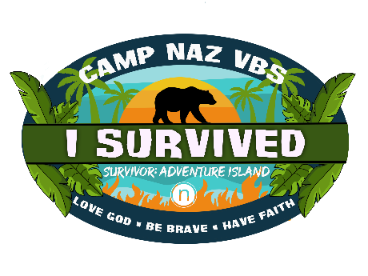
Camp Naz VBS 2022 Donation List

- Hula Hoops (22)
- Sport Cones (30)
- Rings (10)
- Pool Noodles (103)
- Small Trinkets
- Large Parachutes (2)
- Small Beach Balls (3)
- Bubble Solution
- Ping Pong Balls (310)
- Plastic cups (250)
- Baby Pools (4)
- Poster Board (2)
- Long, Wooden Boards (7)
- Old bike tires (or tires of any kind) (15)
- Buckets (10)
- Water Squirters (20)
- Giant Inflatable Balls (2)
- Inflatable Pool Raft (10)
- Potato Sacks (10)
- Giant Ropes (2)
- Regular Size Beach Balls (22)
- Small Rope (5)
- Frisbees (10)
- Sponges (20)
- Milk Crates (10)
- Water Balloons (500)
- Limbo Stick (1)
- Popcorn (10 big GFS bags)
- Animal Crackers
- Goldfish Crackers
- Gluten Free Pretzels
- Gluten Free Oreos
- Tiny Water Cups (2,100)
- Small Plates (2,100)
- Popsicles
- Cotton Candy Bags
- Utensils (400)
- Large Plastic Plates
- Napkins (2,100)
- Band Aids
- Ice Packs

